Assignment 4
[ Loops and Iterative Statements ]
Name: Atharvanath Jha
Section A, Roll no. 38

Question1: Write a program using while loop to find the factorial of a number by taking the number as a user input.

#include<stdio.h>
int main(){
int num, factorial = 1;

printf("\nEnter the number whose factorial you want: \n");
scanf("%d", &num);

int disp_num = num;

while (num > 0){
factorial = factorial * num;
num--;
}

printf(" \n %d! is: %d \n", disp_num, factorial );

return 0;
}

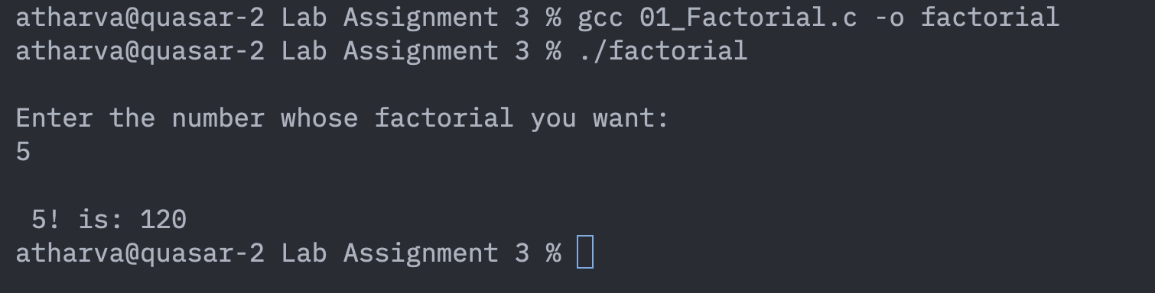

Question1-b. Write a program to print the multiplication table of the desired number.

#include<stdio.h>
int main(){

int num, lim;

printf("\nEnter the number whose table you want to print: \n");
scanf("%d", &num);
printf("\nEtner the limit till where you want to print the table: \n");
scanf("%d", &lim);

for(int i = 1; i <= lim; i++){
printf("\n%d x %i = %d", num, i, num*i);
}

printf("\n");

return 0;
}

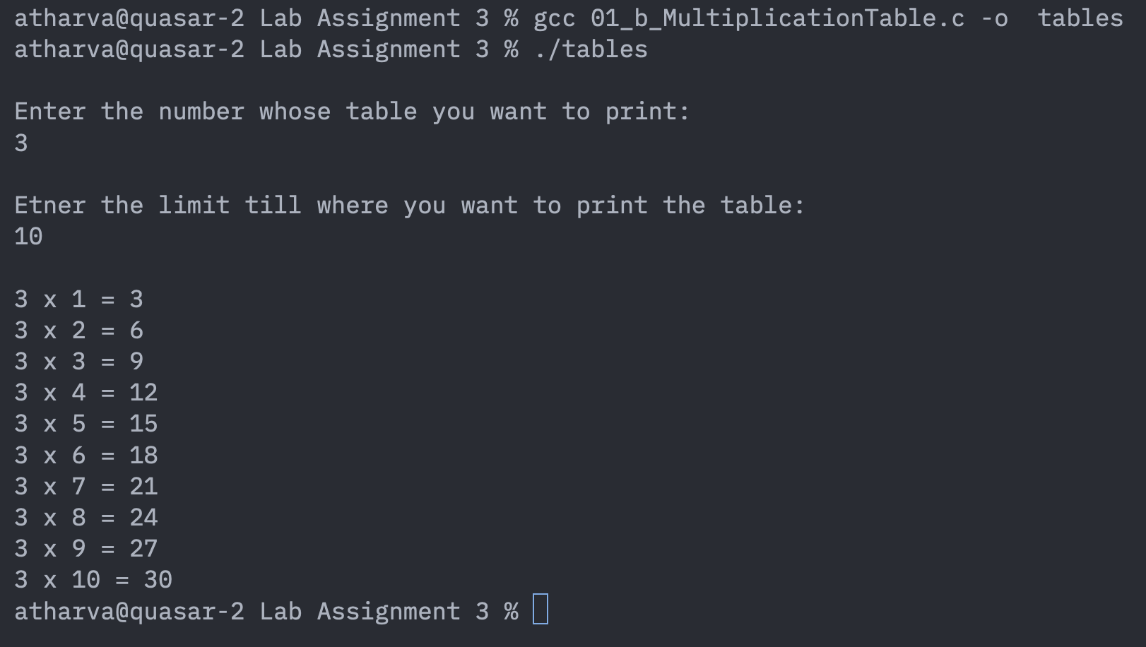

Question2: Write a program to read in numbers until the number -999 is encountered. The sum of all numbers read until this point should be printed out.

Question3: Keep reading in integers until one integer larger than 100 is not input. For example: 4, 90,35, 78, 110 QUIT! (since 110 is bigger than 100).

#include<stdio.h>
int main(){
int a;

printf("\nPlease enter the value: ");

do{
printf("->");
scanf("%d", &a);
printf("\n%d\n", a);
} while(a<100);

return 0;
}

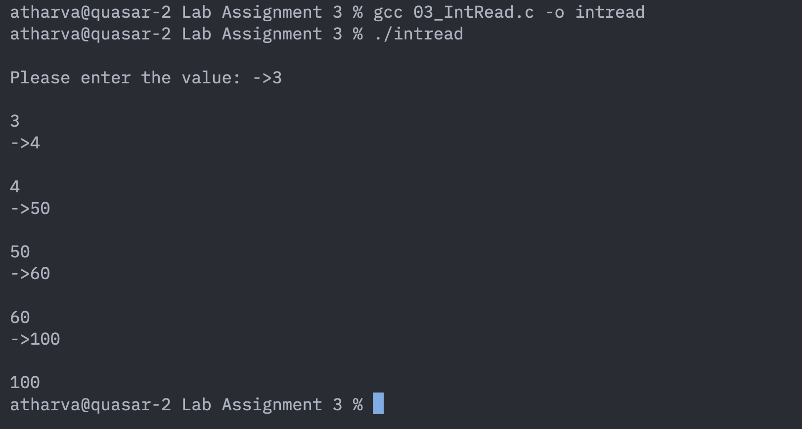

Question4: Read in 20 integers and count the even numbers.

#include <stdio.h>
int main(){
int n;
int i=1;
printf("\nEnter the number: \n");
do{
printf("->");
scanf("%d", &n);

if(n%2==0){
printf("\n %d is an even number.", n);
}
i++;
}while(i < 20);
return 0;
}

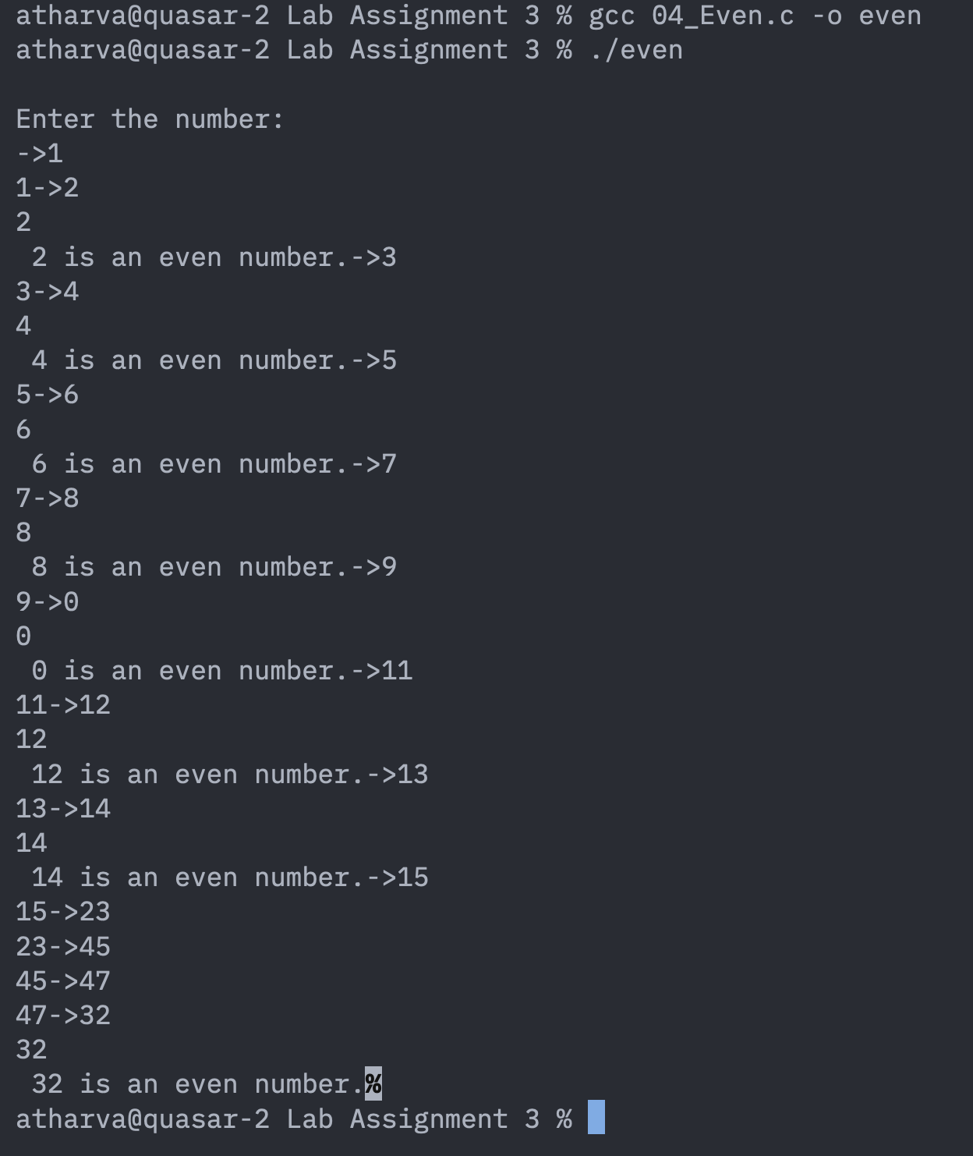

Question5:Print the given patterns -

5-a:

#include<stdio.h>
int main(){
int i, j;

for(i = 1; i <= 5; i++){

printf("\n");
for(j = 1; j < i; j++){
printf("*");
}
}

printf("\n");
return 0;
}

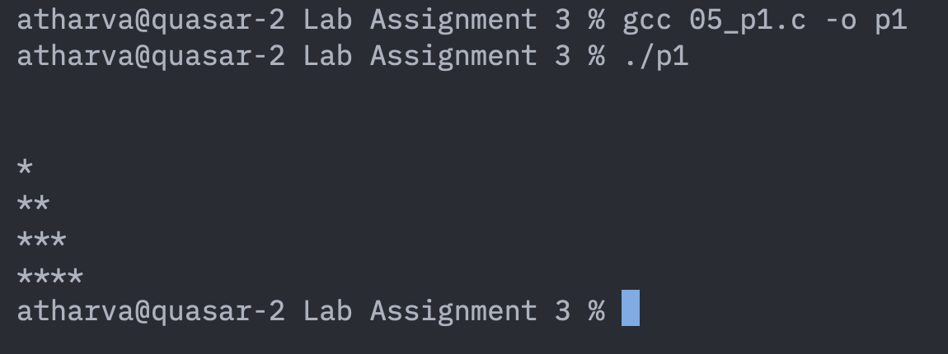

5-b:

#include<stdio.h>
int main(){
int i, j, n;

printf("\nnumber of rows: ");
scanf("%d", &n);

for(i = 1; i <= n; i++)
{
for(j = 1; j <= n - i; j++)
{
printf(" ");
}
for(j = 1; j <= i; j++)
{
printf("*");
}
printf("\n");
}

return 0;
}

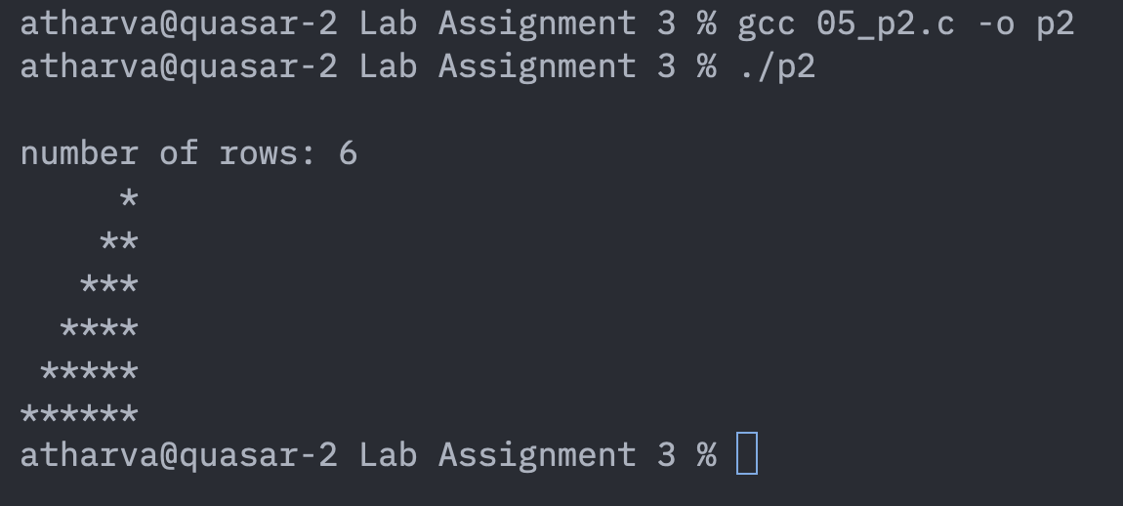

5-c:

#include<stdio.h>
int main(){
int i, j, n;

printf("\nnumber of rows: ");
scanf("%d", &n);

for(i = 1; i <= n; i++)
{
for(j = 1; j <= n - i; j++)
{
printf(" ");
}
for(j = 1; j <= 2*i; j++)
{
printf("*");
}
printf("\n");
}

return 0;
}

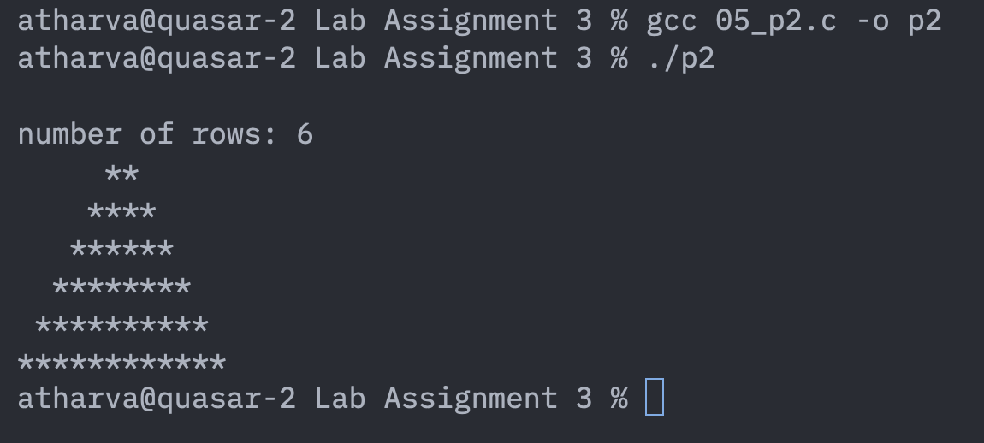

5-d:

#include<stdio.h>
int main(){
int i, j, n;

printf("\nnumber of rows: ");
scanf("%d", &n);

for(i = n; i >= 1; i--)
{
for(j = 1; j <= n - i; j++)
{
printf(" ");
}
for(j = 1; j <= i; j++)
{
printf("*");
}
printf("\n");
}
return 0;
}
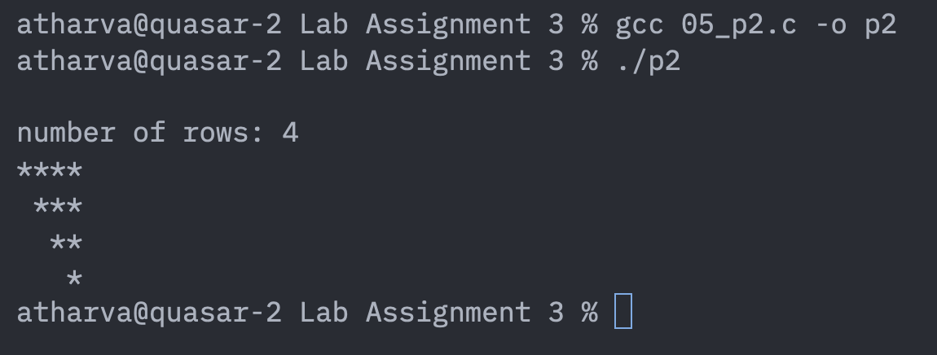
5-e:
#include<stdio.h>
int main(){
int i, j, n;

printf("\nnumber of rows: ");
scanf("%d", &n);

for(i = n; i >= 1; i--)
{
for(j = 1; j <= i - n; j++)
{
printf(" ");
}
for(j = 1; j <= i; j++)
{
printf("*");
}
printf("\n");
}

return 0;
}
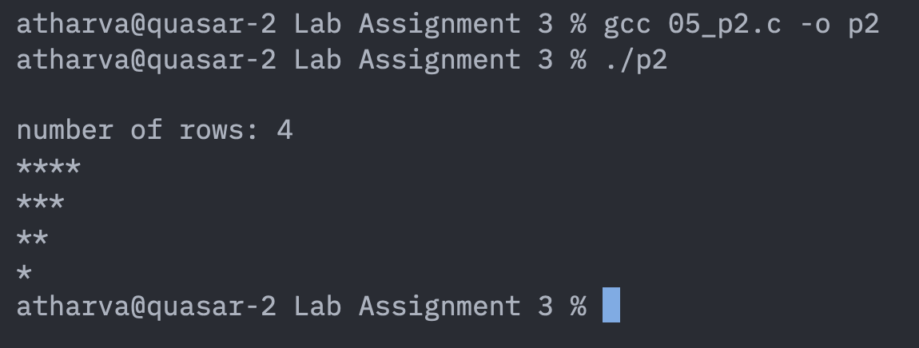

5-f:
#include<stdio.h>
int main(){
int i, j, n;

printf("\nnumber of rows: ");
scanf("%d", &n);

for(i = 1; i <= n; i++)
{
for(j = 1; j <= n - i; j++)
{
printf(" ");
}
for(j = 1; j <= 2*i; j++)
{
printf("*");
}
printf("\n");
}

return 0;
}
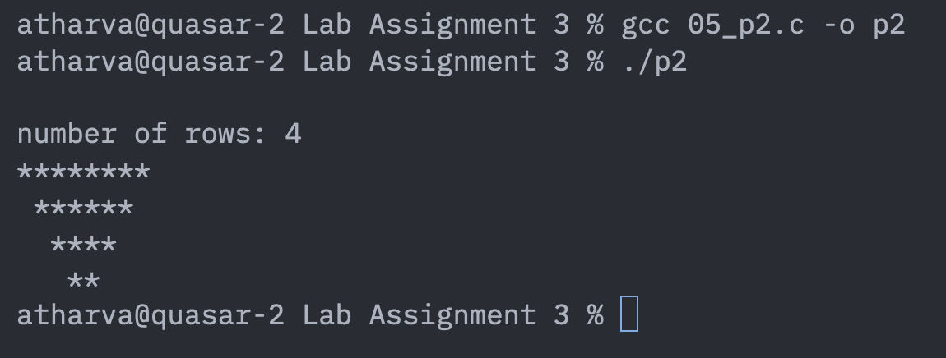

5-g:
#include<stdio.h>
int main(){
int i, j, n;

printf("\nnumber of rows: ");
scanf("%d", &n);

for(i = 1; i <= n; i++)
{
for(j = 1; j <= n - i; j++)
{
printf(" ");
}
for(j = 1; j <= n; j++)
{
printf("*");
}
printf("\n");
}

return 0;
}
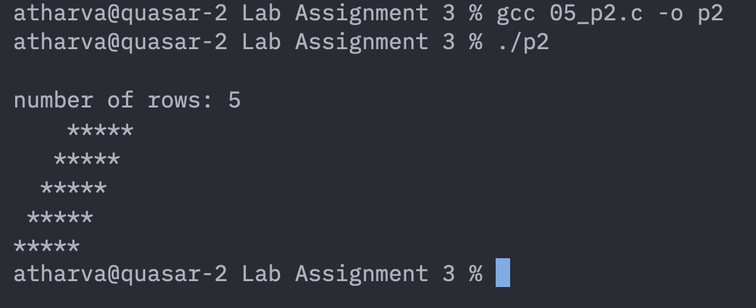

5-h:

Question6:
A sensor records the room temperature every 4 hours for 24 hours. Write a C program using for loop to input all the temperature.

#include<stdio.h>
int main(){

float temp[6];

printf("Enter the tempterature readings in Kelvin: ");
for(int i=0; i<6; i++){
scanf("%f", &temp[i]);
}

printf(" \nThe given temperature readings are:\n");
for (int i = 0; i < 6; i++) {
printf("%f ", temp[i]);
}
printf("\n");

float min = temp[0];
float max = temp[0];
//Finding the largest reading
for(int i=1; i<6; i++){
if(max < temp[i]){
max = temp[i];
}
if(min > temp[i]){
min = temp[i];
}
}

printf("\n %f is the max temperature, and %f is the least temperature.", max, min);

return 0;
}
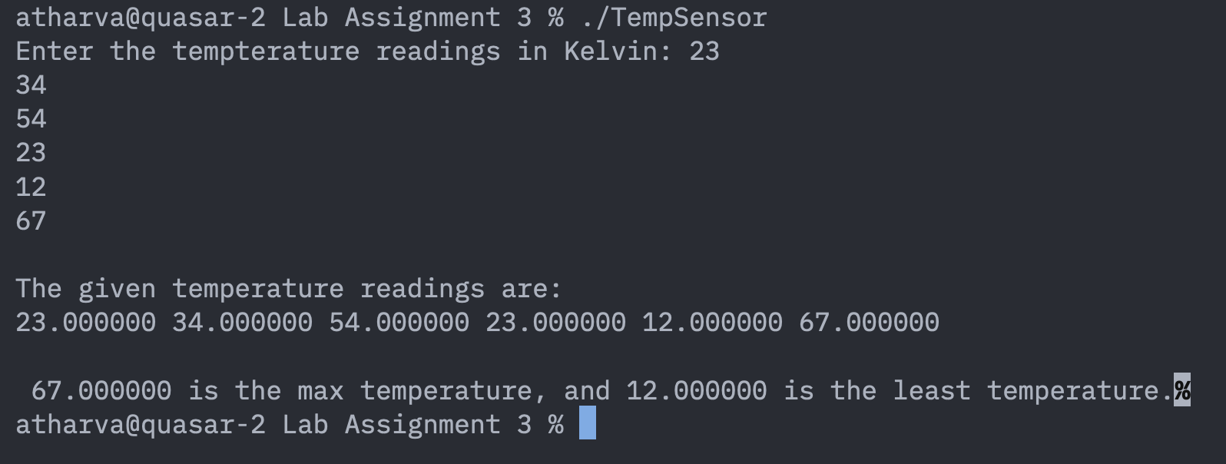

Question7: Using the while loop, write a C program to print the Fibonacci sequence up to N numbers, where N is entered by the user at run time. (NOTE: The Fibonacci sequence is a series of numbers in which each number is the sum of the two preceding ones. The starting two preceding numbers are 0 and 1. The Fibonacci sequence till 10 numbers are 0, 1, 1, 2, 3,5, 8, 13, 21, 34).

#include<stdio.h>
int main(){
//To print Fibonacci Sequence
int N, i;
int num1 = 0;
int num2 = 1;
int sum;

printf("enter the upper limit: \n");
scanf("%d", &N);

printf("The fibonacci sequence is: ");
printf("%d \n %d \n", num1, num2);

for(i=1;i <=N-2; i++ ){
sum = num1 + num2;
printf("%d \n", sum);
num1 = num2;
num2 = sum;
}

return 0;
}
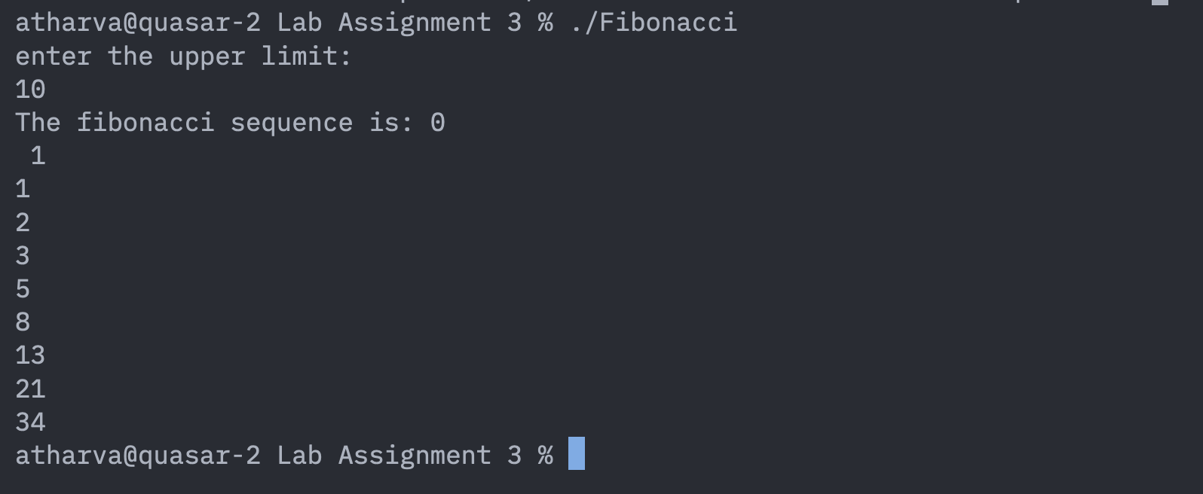

Question8:
You are driving a car with N litres of fuel. With 1 litre of fuel, you can cover 5 kms distance. Write a C program using a while loop to calculate how many kilometres you can travel until the fuel becomes 0, and print the fuel left after every 10 kilometres. (For example: If N = 20 Liters, and you travelled 10 kms, fuel left 18 Liters, then travelled 10 kms, fuel left 16 Liters and so on).

#include <stdio.h>

int main()
{
int N;
int distance = 0;

printf("Enter the amount of fuel in litres: ");
scanf("%d", &N);

while (N >= 2)
{
N = N - 2;
distance = distance + 10;

printf("Travelled %d km, fuel left = %d litres\n", distance, N);
}

printf("Total distance travelled = %d km\n", distance);

return 0;
}
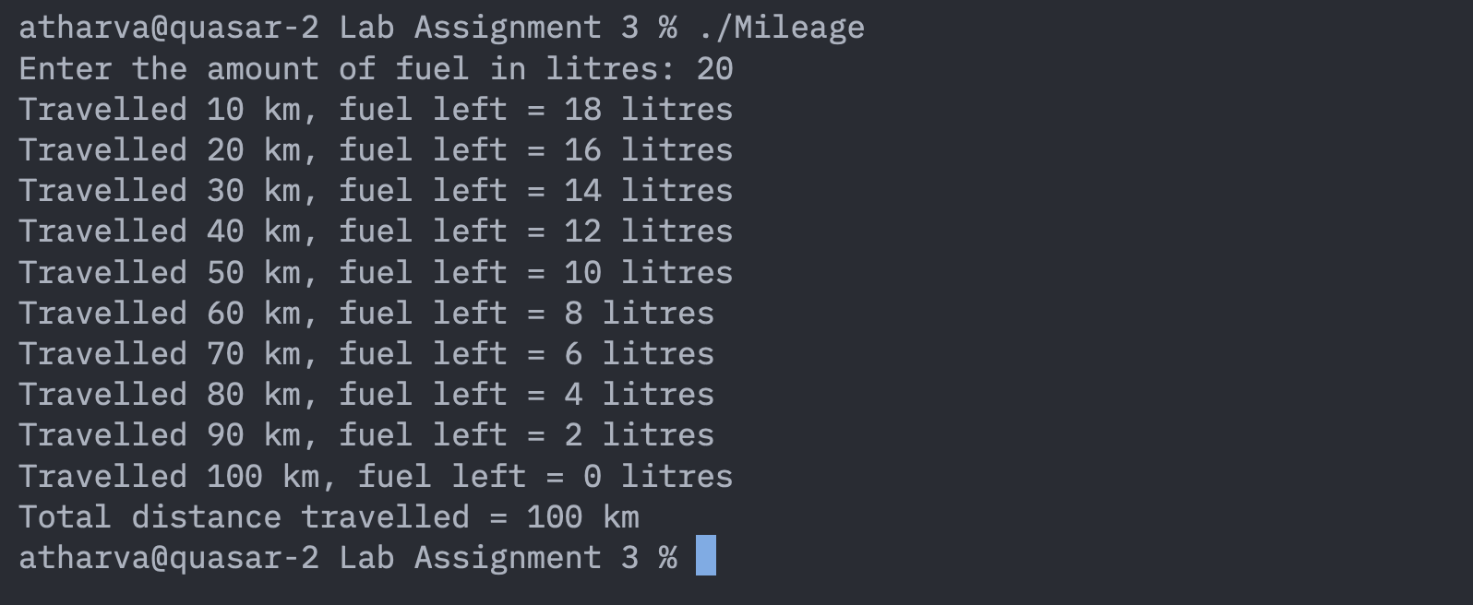

Question9: At a cinema hall, N tickets are available. Each person in the queue buys between 1 to 4 tickets. Write a C program using a while loop to simulate the sale of tickets until all tickets are sold and display the number of tickets left after each purchase. The starting N tickets should be entered by the user at run time (For example: If N = 10, and you entered tickets required = 4 then tickets available = 6; you entered tickets required = 3 then tickets available = 3, and soon).

#include<stdio.h>
int main(){
int N, k;

printf("\nTotal tickets: \n");
scanf("%d", &N);

while(N>0){
printf("\nAvailable tickets: %d", N);
printf("\nHow many do you want: ");
scanf("%d", &k);

if (N < k){
printf("\n Oops! not enough tickets.\n");
}
N = N - k;

}
return 0;

}
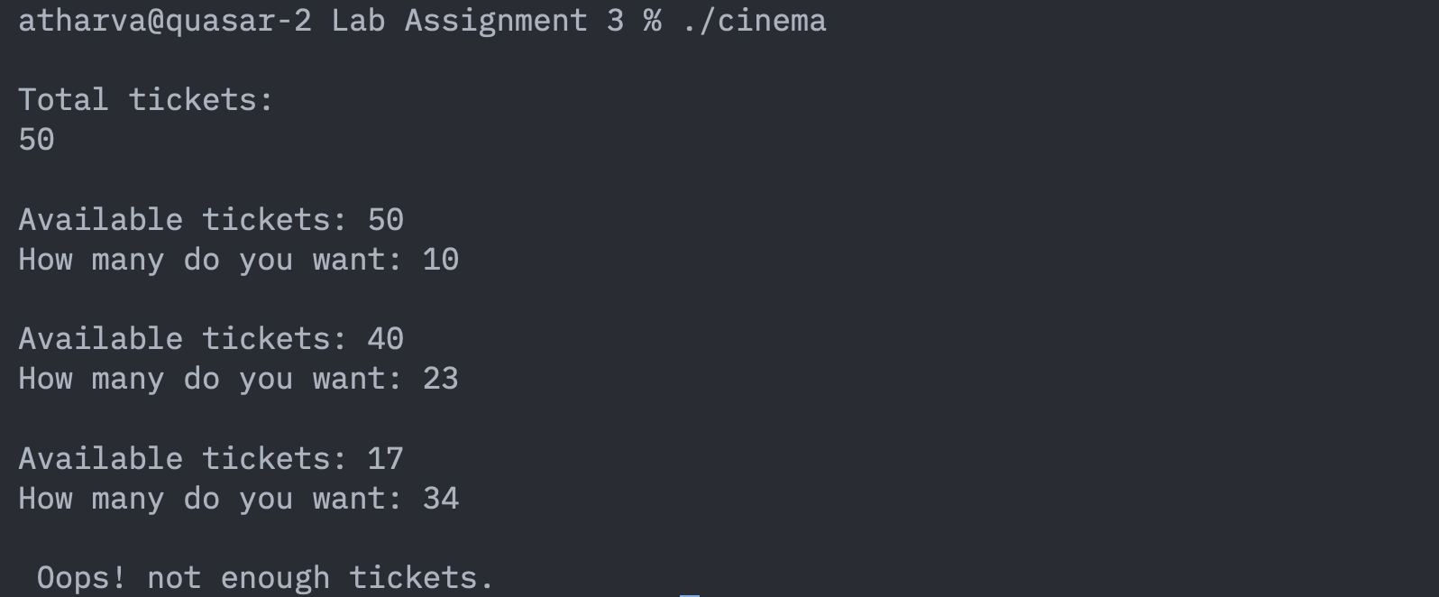

Question10:
You deposit ₹10,000 in a bank account with 5% annual interest. Each year, the bank adds interest to your balance. Write a C program using a while loop to calculate how many years it will take for your balance to exceed ₹15,000. (For example: Year 1, ₹10,500.00; Year 2, ₹11,025.00; Year 3, ₹11,576.25, and so on).

#include<stdio.h>
int main(){
float time=1;
float amt = 10000;
float interest = 5;

printf("\nAmount dipostied: %f", amt);
printf("\nRate of interest: %f%% p.a.", interest);

while(amt <= 15000){
amt = amt + ((interest/100)*amt);
time++;
}

printf("\nThe final amount is %f after %f years.", amt, time);
}
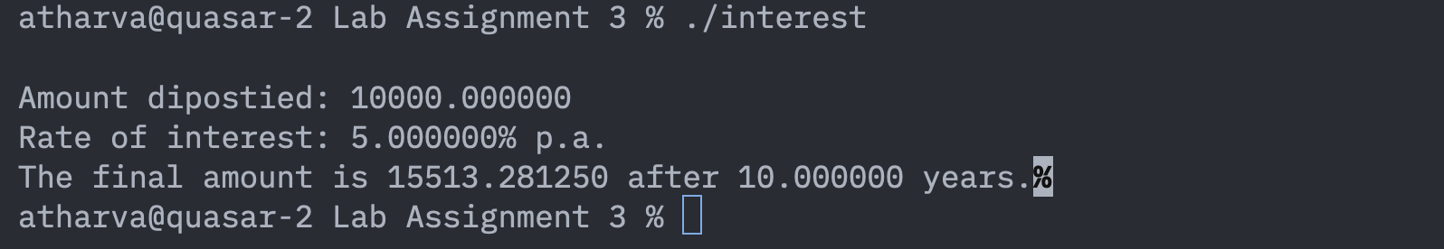

Question11: Write a C program using a do-while loop for a number guessing game. The computer has a secret number (for example, 49). Ask the user to guess the number until they get it right. After each wrong guess, tell them if their guess was too high or too low.

#include<stdio.h>
#include<stdlib.h>
int main(){
int num;
int guess;

num = rand() % 100+1;

do{
printf("\nEnter your guess between 1-100: ");
scanf("%d", &guess);

if(guess > num){
printf("\nGuessed too high!!");
}

else if(guess < num){
printf("\nGuessed too low!!");
}

else{
printf("Sahi Jawab!!! 7 Crore!!!");
}
}while(guess != num);

return 0;
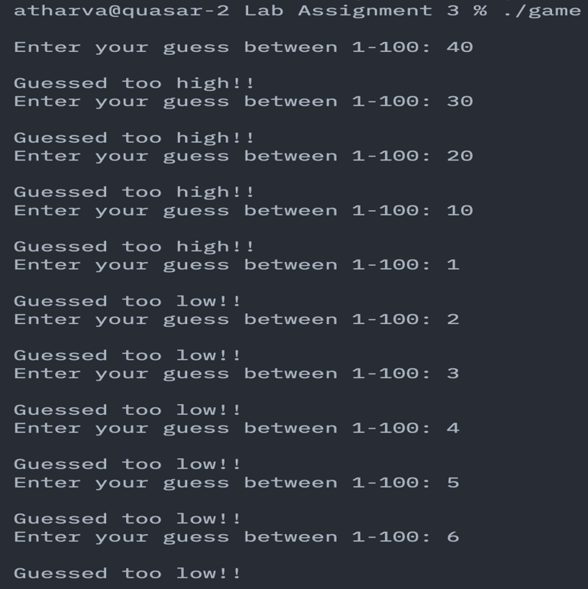
}
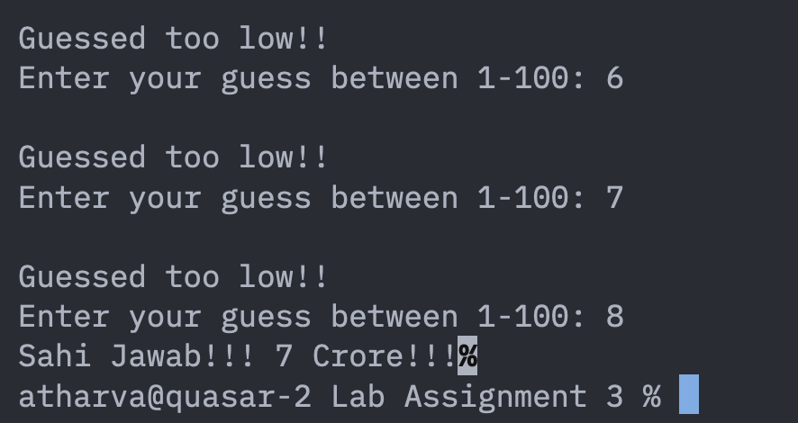

Question12:
Write a C program using a do-while loop that asks the user to enter their weight (in kg) and height (in meters). Make sure both values are positive. If not, keep asking until valid numbers are entered. Then, calculate the Body Mass Index (BMI) using the formula: BMI = weight (Kg)/height(m2). After that, tell the user if they are overweight (BMI > 25) or not.

#include<stdio.h>
int main(){
float wt, ht;

do{
printf("\nEnter weight(in kg): ");
scanf("%f", &wt);
}while(wt<=0);

do{
printf("\nEnter height(in m): ");
scanf("%f", &ht);
}while(ht<=0);

float bmi = wt/ht;

if(bmi > 25){
printf("\nOverweight!");
}

else{
printf("\n You are fine.");
}
}
